Explanation
The database consists of seven tables organized around two core functions: tracking participant behavior and storing content for recommendations.
User-Centric Tables
user is the central table that anchors all participant data. When a participant registers, a user record is created containing their identity information (name, email).
user_preferences stores each participant's research settings in a one-to-one relationship with user. This includes their `birth_year` (used to calculate which content falls within their nostalgic "reminiscence bump" period of ages 10-22), their `experiment_group` assignment (treatment receives nostalgic recommendations, control receives standard recommendations), and their `habit_type` (exercise or smoking cessation). The `selected_movie_ids` and `selected_song_ids` fields store the content they chose during onboarding, which seeds the recommendation algorithms.
daily_habit_logs captures daily check-ins from participants. Each record includes whether they `completed` their habit that day and optional `notes` (journal entries). The `stress_level` and `emotion` fields are automatically populated by NLP models that analyze the journal text—these values become context features for the recommendation system.
content_feedback records participant responses to the question "Does this bring back memories?" after viewing a recommendation. The `brings_back_memories` boolean serves as the reward signal for the contextual bandit algorithm. The `content_type` field indicates whether the feedback is for a song or movie, and `content_id` stores the corresponding ID.
Content Catalog Tables
songs contains ~100,000 tracks from Spotify with audio features (danceability, energy, valence, tempo, etc.) and metadata. The `year` field enables filtering for nostalgic content (10+ years old).
song_vectors stores 128-dimensional embeddings for each song, enabling similarity-based recommendations via PostgreSQL's pgvector extension. Each song has exactly one corresponding vector.
movies contains ~80,000 titles from the MovieLens dataset with genre information and aggregate ratings. Like songs, the `year` field enables nostalgia filtering.
Key Relationships

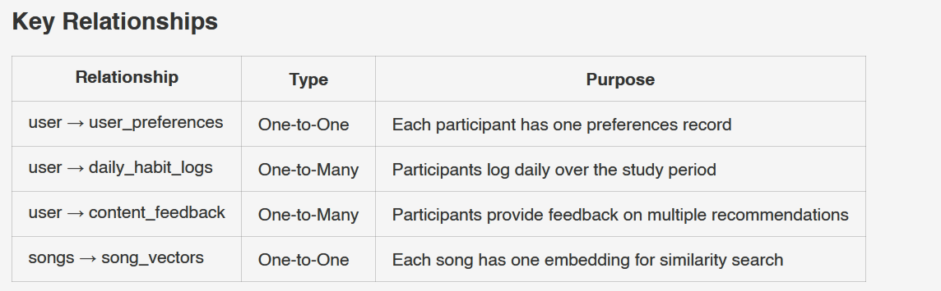
!NOTE
The `content_feedback` table uses a polymorphic pattern—`content_id` can reference either `songs.id` or `movies.id` depending on `content_type`. This avoids needing separate feedback tables for each content type.

